**Relational Database Contd**

* Subnet groups:
  + When we create a rds instance we need to give an option to select atleast two AZs in a region. Subnet groups allow us to do that.
  + We can select the network (vpc-id) and any subnets belonging to az’s  
    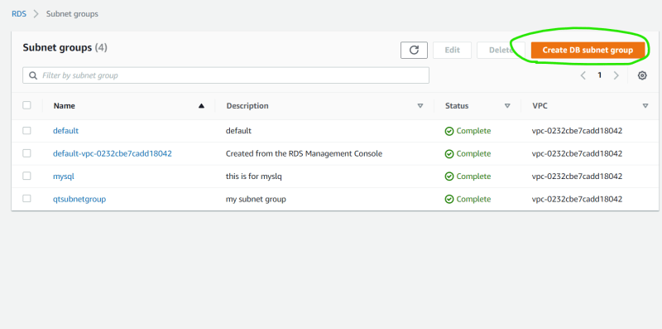  
    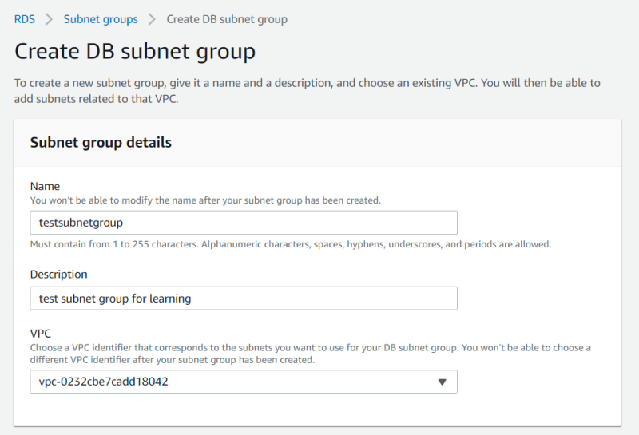  
    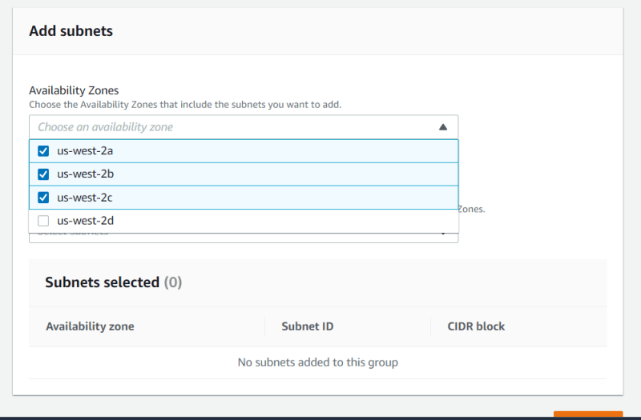  
    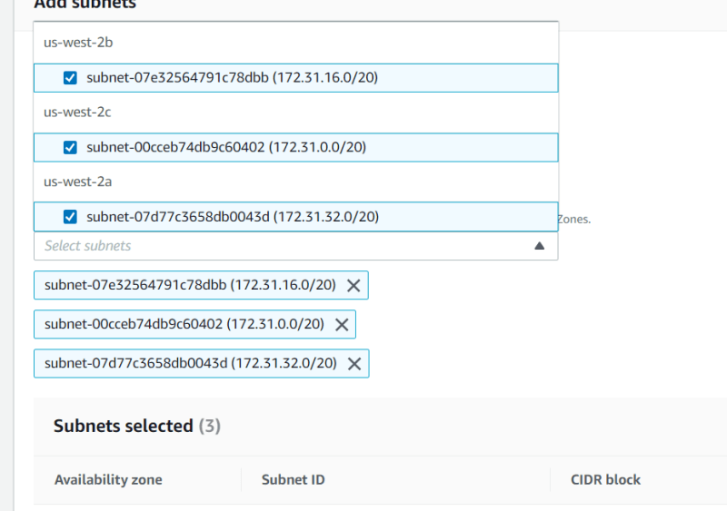  
    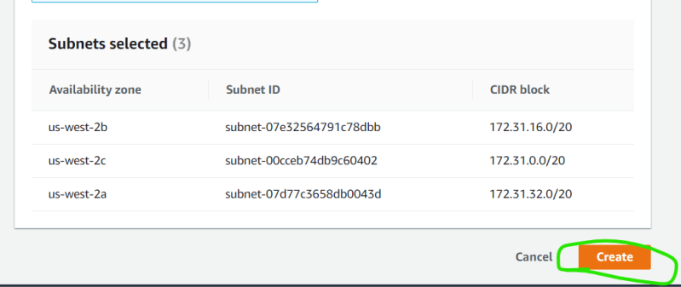
  + Once the subnet group is created we can use this in rds creation which will directly select the network and subnets and indirectly select the AZ’s  
    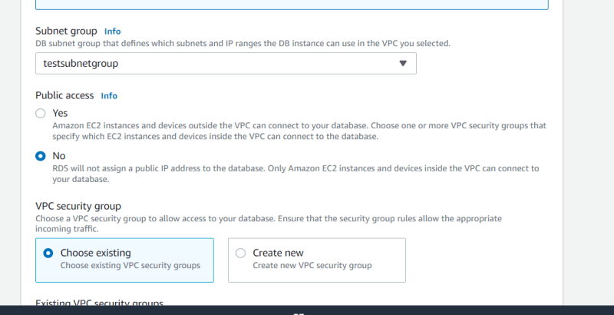
* Parameter Groups:
  + Database parameters that specify how the database is configured.
  + These parameters set the DB engine behavior parameters  
    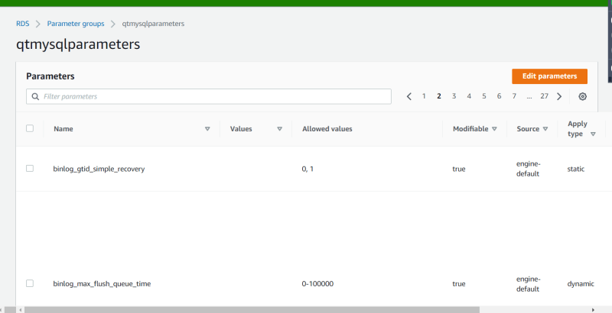
* Option Groups:
  + Some DB Engines offer additional features that make it easier to manage data and databases and to provide additonal security to your database

**Database Instance Classes**

* <https://docs.aws.amazon.com/AmazonRDS/latest/UserGuide/Concepts.DBInstanceClass.html> for the official documentation

**Database Instance Storage**

* AWS Provide 3 options
  + General Purpose: Good for all normal usecases, we get decent disks with normal disk io performance
  + Provisioned IOPS: In here we can choose the speed of our disks (unit is IOPS). This is costlier option but faster as well
  + Magnetic: Is still existing in AWS for backword compatibility
* Exercise -1 : Create an estimate for using mysql database with multi az, we need atleast 6 vCPU and this is for normal workloads and storage size required is 150 GB which might grow to max of 1TB
* Exercise-2: Create an estimate for using postgres data base with multi az, we need at atleast 24 GB RAM with faster memory and storage also needs to be faster, the disk size/storage size required is 50 GB and can grow till 100 TB at a max.